Men’s Soccer Game
WHITE OUT !
Vs.

Who: Tiffin Dragons v. Saginaw Valley Cardinals
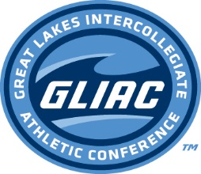
What: GLIAC Conference Game
When: Friday October 23, 2015 @ 2:30
Where: Paradiso Sports Complex
WHY: Free Pizza
Free T-Shirts (First 45)
Free TU Cups
GO DRAGONS!

