Table of Contents
Service/Company Overview pg 3

Situation Analysis – SWOT pg 4-5

Marketing Research pg 6

STP Analysis pg 7

Marketing Strategy/Implementation pg 8-9

Financial Projections pg 10

Appendix/References pg 11

Service/Company Overview
Our company will be a sports facility, called Tiffin Sports Academy – For Elite and Superior Sports
We will have athletic fields, and courts, along with a weight room that, teams, and members can use.
We will offer top youth sport teams, in the effort to bring in long lasting customers. Also, being able to help give the youth a place to go spend their time.
Some sports that we will offer teams for, Football, baseball, basketball, soccer, volleyball, power lifting and bodybuilding.
In addition, we will offer camps, individual lessons, and even weight training sessions.
Mission Statement – If you want a better life make it happen – “Fit is Life”
Our Competitive advantage will be the fact that we offer a wide variety of sports, physical training sessions with professional trainers, and unique events and activities, involving the local schools and community.
We will be very unique for the Tiffin area, there is nothing in this area that incorporates all of these into one facility.
We will build a network of people that have a background in sports, either at the college level or professionally. This will only help to attract clientele because everyone wants to train with the best!
Example of facility layout below: 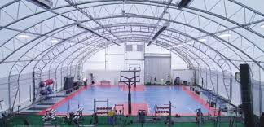
Situation Analysis – SWOT
SWOT
Strengths:
Everyone wants a place they can call home, and further a place where they can accomplish their goals. Whether they are on the field or in the gym and we incorporate both of these ideas for our clients.
We will have a variety of activities for children and teens of all ages. On top of that while the children are practicing their certain sport we have a gym for the parents to get their own workouts in. We understand the difficulty of wanting to be in shape and having a limited amount of time. The way we are set up it allows for them to accomplish all of this at once
We will have employees with a diverse sports background that have played the specific sport they are instructing. We want our clients to be the best so we will offer them the best.
A large amount of people want to live a healthy lifestyle and whether they know what needs to be done, or they need some assistance and guidance to help them maintain a healthier lifestyle. This is what we are here for, providing hands on learning with the supervision of our highly trained staff on hand.
Weakness:
It will be difficult at first to find the clientele that are willing to leave their previous facility that they call home. We will have to show them why we are superior and that we have more to offer them.
A Sports Facility is based off a strong reputation, and built on trust and a relationship between the employees and customers and it takes time to forge this. We will have to prove ourselves to them beyond a reasonable doubt why we are the place to be.
Opportunities:
We have a large area of growth starting in the Tiffin Area and then moving to surrounding towns. There is a vast amount of athletes that either live here or are attending school currently, and have few choices in facilities, and camps that can help improve their teamwork and ethics as well as excelling at the sport.
The market is extremely large and unused. There is not a place these individuals can call home and we want to be this place.
This area has a huge number of individuals that are involved personally in a sport, have a family member that competes regularly, or even those that are just sport junkies.
This will be a facility that has never been seen in this area, and we will be the best.
Threats:
There are some threats that we will have to make sure we are aware of and know how to compete with them in this field. But in Tiffin alone there are only 14 total athletic fields available to the youth throughout all of Tiffin.
They are as follows:
The local YMCA
Planet Fitness
Tiffin Cross-fit
Private teams/leagues in the area:
Tiffin Little League Football
Tiffin League Baseball teams
Indoor field example shown below:
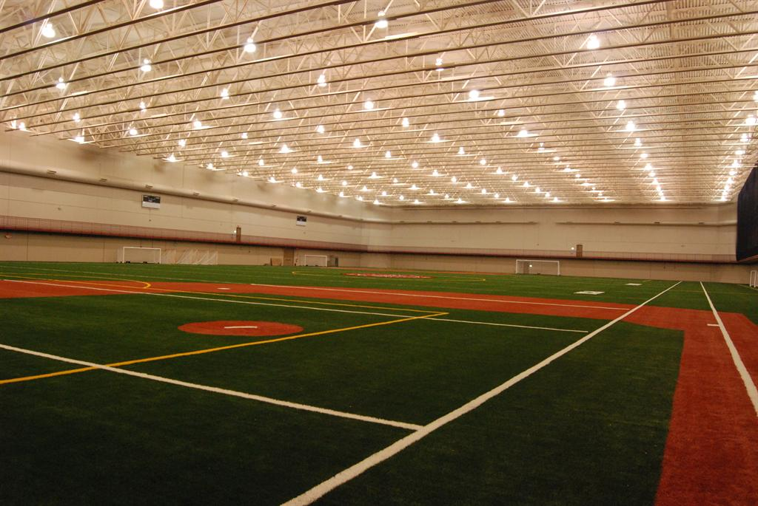

Marketing Research
Any company that is looking to break into a market must develop ways to research the market, to in turn know what they are up against and how to best form their business to attract the desired customers.
To do this we will identify the customer’s wants and needs.
These are the fact that there are many people involved in sports and fitness in this area.
There are mediocre facilities in the area that are open to these individuals.
When someone is playing a sport or working out they want to be the best they can be and this is what we aim to help them do.
Our ultimate goal is to fill these needs and wants and when someone thinks of TSA they think of home and know that there is nowhere else they would rather be.
To attain this information we will conduct surveys and personal interviews of individuals in the area. The athletes at the local colleges, the coaches and players at the high school, and the members of the community.
We will use a combination of Qualitative and Quantitative research
Quantitative – the amount of athletes in the tiffin area.
The number that are involved in college, high school, and youth sports.

Qualitative – The sports that are popular and the number of people involved in these sports
The primary age groups likely to use this facility.
We will use primary data that can be used for a specific task, for example what types of sport teams to offer right away. What type of equipment and training style is most popular.

STP Analysis
Q

TSA

Planet Fitness
Tiffin CrossFit
P

YMCA
Local fields

Customer Analysis
Everyone is welcome! – No discrimination against any religion or race.
We will be targeting lower class, middle class, and upper class. To do this we will be affordable because we understand the fact that just because you may not be wealthy does not mean you or your children may not be involved in sports. Must be able to attract everyone.
We will focus mainly on the younger generations through the college ages. So ages 8-24. We will keep them separate but have opportunities for them all. Not forgetting the parents and other individuals who are still interested in working out and staying in shape ages 25-60.
We will be focusing on those that either reside in Tiffin permanently, or are just here because this is where their school or sport has brought them currently.
Obviously those individuals that are athletically involved and have a love for fitness.

Marketing Strategy/Implementation
We will keep the marketing in-house amongst the owners and our employees that we start out with.
We will attack the advertising aggressively by running ads in the local and school newspapers.
There are opportunities to advertise on televisions so we will run ads on sports channels, including ESPN, Big Ten Network, and NBC Sports. To attract the younger generation and the parents with younger children there will also be ads run on the kid’s channels for example Cartoon Network.
We will utilize social media, having a Facebook page, Instagram, and Twitter to advertise our facility ex. #TSAeliteandsuperiorsports, Tiffin Sports Academy.
Will also broadcast over the radio, during sport functions and events.
Lastly we will personally appear at local school sport functions to show we are a part of the community and to help get our names out there.
An example of one of our ads is shown below:

A successful launch:
To help our company burst into the sports market there are several avenues that we will use.
We will invite high school and college athletes and teams to come in and use our facilities in entirety.
Run camps for the youth to show that we are a part of the community and that we have the ability to teach the children the necessary skills needed to play at a high level.
Promotional activities for specific teams with specialized, high quality instructors in the desired sport, or training sessions.
We will have guest passes that are offered to invite people to try out our facility for free for a week.
We will also offer open house weekends that are open to everyone.
Most importantly we will have days where we bring in certain professional athletes and competitors to gain attention and to show that we can back up what we say we train like and with the best.
Time Frame:
We will advertise six months before and after, and we will start offering the promotional activities for the first six months we are open and some of them will not go away but will happen randomly when we decide it is necessary and want to attract newer clients.
Out-door field layout example below:
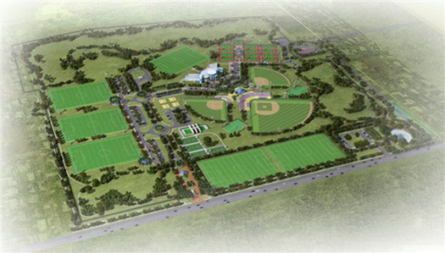

Financial Projections
We will be building high quality, top notch facilities fields, courts and weight rooms.
The initial startup we will need to invest or receive a loan of $500,000 - $800,000.
This will help us get off the ground with securing a building, hiring employees, purchasing equipment, and of course building the fields and sport venues that we will offer.
This is a high startup cost, but a sports facility once it is up and running will be self-sustaining as long as we can secure loyal and repeat customers.
The costs that go with participating on our specific sport teams along with membership costs, will turn our business into a powerhouse in this market.
In the first six months of operations we believe to be able to have a revenue of $200,000 or more.
In the first year a revenue of $500,000 or more
Lastly by the fifth year we believe we can be a million dollar organization yearly.

Appendix/References

References:

FieldTurf (2015).Cost Analysis: Retrieved on December 1, 2015 from: http://www.fieldturf.com/en/fieldturf-difference/cost-analysis
Indoor Soccer Facility Business Plan: Retrieved on December 1, 2015 from: http://www.bplans.com/indoor_soccer_facility_business_plan/strategy_and_implemen tation_summary_fc.php
Youth Sports (2015). Youth Sports: Retrieved on December 1, 2015 from: https://www.tiffinparks.com/Youth%20Leagues.html
Tiffin Park & Recreation (2015). Ball Diamonds, Sports Fields, and Athletic Courts: Retrieved on December 1, 2015 from: https://www.tiffinparks.com/parks-facilities/facilities/ball- diamonds-sports-fields-and-athletic-courts/

