Mid-American Conference: East Division
University of Buffalo University of Akron
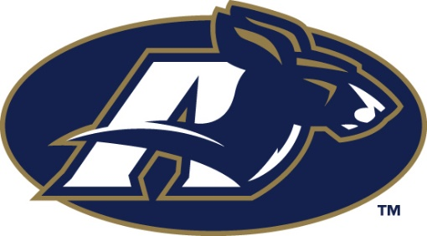

Head Coach: Lance Leipold Head Coach: Terry Bowden
Mascot: Victor E. Bull Mascot: Zippy
Colors: Blue/White Colors: Blue/Gold
Bowling Green State University Kent State University
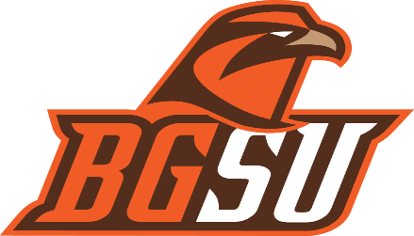

Head Coach: Mike Jinks Head Coach: Paul Haynes
Mascot: Freddie/Frieda Falcon Mascot: Flash the Golden Eagle
Colors: Orange/Brown Colors: Navy Blue/Gold
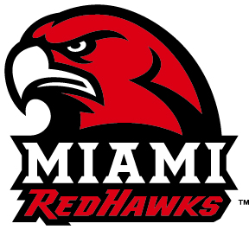
Miami of Ohio University Ohio University

Head Coach: Chuck Martin Head Coach: Frank Solich
Mascot: Swoop the Redhawk Mascot: Rufus the bobcat
Colors: White/Red Colors: White/Hunter Green
Mid-American Conference Football Worksheet - Rules

First Date of Practice Permitted: August 10, 2016
First Date of Competition: September 3, 2016
Travel Party Size: 80
Complimentary Passes (Players / Staff): 4 per player/coach
Appeal Procedures: An appeal must be made within 3 days of the official ruling. From there the conference will meet and come to a unanimous decision in 10 days.
Determining Conference Champions: Winner of the East Division plays the Winner of the West Division
Tiebreaker Procedure at end of regulation:
- Head-to-head record among tied teams
- Record of tied teams within the division (versus rank order, highest to lowest, of division teams)
- Comparison of conference winning percentage of cross-over opponents of tied teams

Conference Awards (Weekly, Season, Nomination Procedure)
Each team will be able to have one player nominated for each award listed below:
Athlete Of the Week, Offensive Player of the Year, Defensive Player of the Year, Special Teams Player of the Year, Freshman Player of the Year, Vern Smith Leadership Award, Coach of the Year
*The Vern Smith award will be decided by the head coaches of the conference and the MAC News Media Association will determine the rest of the awards
Official Ball: Nike
Official Uniform: Nike
Commercial Logo Restrictions: Commercial use is subject to licensing standards administered by the Licensing Program Coordinator. There will be one logo used on collar of the player’s jersey next to their team logo. It will only consist of the name and the commercial logo of the title sponsor. It will only be 4 inches wide and 4 inches in length and will not be covering any of the schools logos.
Drug Testing Protocol (who and when): Each team will be subject to a random player being selected for each semester of the year. The selection process will be completely random and the athlete will have 24 hours to comply with the drug testing protocol or face an immediate failure in their result. If an athlete is found to fail the drug test the following procedure will be followed. First offense will result in the athlete being suspended for half of the present season and they will be required to attend the schools drug prevention class. Second offense will result in suspension of the athlete for the entire season and dismissal from the university.
Concussion Protocol: Any player showing the signs of a concussion will be immediately removed from the contest and will not be eligible to return to competition or practice until cleared by a physician. They will be required to weekly see the team’s physician to monitor the signs of their concussion until they are cleared. Once they are cleared by the physician they will be allowed to begin practicing the next week and at the end they must be reevaluated. If the athlete is cleared completely then they will be allowed to reenter the competition with the team.
Unsportsmanlike Conduct: Each player or coach will receive one warning resulting in a penalty, which will be a loss of 15 yards, after the second occurrence they will be removed from the current game and will sit out one additional game.
Instant Replay: This can only occur is there is evidence that an error was made in the initial on-field ruling or the play is reviewable. Reversal of the on-field ruling can only occur from indisputable video evidence, and the call would have an impact on the game. Each coach may use a timeout to challenge a call on the field, if they are successful in the challenge they keep their timeout and have an additional challenge. If the call is not over-turned the team loses a timeout.
Hospitality / Press Box Restrictions: Only officials, players, coaching personal, and television/broadcasting crew is allowed in the press box.
Television Revenue Sharing Plan: Each team in the conference will retain 50% of the television revenue that they have negotiated with the opposing team and the media channel. The remaining 50% will be given to the conference and divided evenly amongst the teams in the conference.
Bowl Game Revenue Sharing Plan: Each team that secures a Bowl Game will retain 50% of the television revenue and the remaining 50% will be divided evenly amongst the remaining teams in the conference.
Conference Operational Budget Information
Ticket Prices: $5 Students / $10 General Seating
Ticket Sales: 30% Students / 70 % General Seating
Merchandise Sales: $10 per person average
Parking Prices: 20 % of Capacity X $10 per vehicle
Per Diem (Meals) $ 10 Breakfast $ 15 Lunch $20 Dinner
# Persons per Hotel Room: 4
Commercial Air Travel Price Locator: Expedia
Ground Transportation (Charter Bus) Mileage Fee: $.50 per mile
Ground Transportation (Charter Bus) Driver Fee: $15 per hour
Concession Vendor: Sodexo
Percentage of Concession Sales: 60% vendor, 40% hosting school
Total Concession Sales/Game ($5 per fan on average * Stadium Capacity)
Net Concessions/Game (Total Concessions * 40%)
Media Guide Profit (.25 Stadium Capacity – Sale price less printing fee)
Home team receives $5 dollar profit from media guide profit if, each stadium prints .25 of stadium capacity they will sell media guides for $6
Security Fee per Game: $8.10 per hour
Medical Fee per Game: $12 per hour

University of Buffalo Team Sheet
Head Coach: Lance Leipold
Athletic Director: Allen Green
Mascot: Victor E. Bull
Colors: Blue/White

This University is Located in Buffalo, New York
They are a part of the Mid-American Conference and are a part of the East Division
Their home Stadium is UB Stadium
Athletic Nickname: Bulls
The Stadium Seating Capacity is 29,013
2015 Record: 5-7, (3-5 Conference)
They didn’t receive a bowl appearance in 2015-2016
(Last bowl appearance was in 2013 in the Famous Idaho Potato Bowl they lost)
The University of Buffalo’s total enrollment is 29,944 students
Of these students 53% or 15,870 are male and 47% or 14,073 are female
In-State Tuition cost: $22,062
Out-of-State Tuition cost: $23,270
Football Teams APR: 970
Faculty Athletic Representative (FAR): Jim Atwood, his academic area is chemistry/science
Number of Athletic Administrators: 13
Number of Female Athletic Administrators: 6

HEAD COACHES
# Full Time Male Head Coaches - Men's Teams | 6
# of Full Time Female Head Coaches - Men's Teams | 0
# Full Time Male Head Coaches - Women's Teams | 1
# of Full Time Female Head Coaches - Women's Teams | 5
Ave Annual Institutional Salary per FTE - Men's Teams | $136,284
Ave Annual Institutional Salary per FTE - Women's Teams | $82,326
ASSISTANT COACHES
# Full Time Male Asst. Coaches - Men's Teams | 13
# of Full Time Female Asst. Coaches - Men's Teams | 0
# Full Time Male Asst. Coaches - Women's Teams | 0
# of Full Time Female Assist Coaches - Women's Teams | 4
Ave Annual Institutional Salary per FTE - Men's Teams | $49,561
Ave Annual Institutional Salary per FTE - Women's Teams | $33,316
ATHLETIC STUDENT AID
Total Men's Teams | $4,837,696
Total Women's Teams | $3,464,166
Percent of Aid to Men's Teams | 58%
Percent of Aid to Women's Teams | 42%
TOTAL REVNEUE + REVENUE & EXPENSE SUMMARY
Total Revenues Men's Teams | $12,446,374
Total Operating Expenses Men's Teams | $2,497,617
Total Revenues Minus Total Expenses Men's Teams | $9,948,757
Total Revenues Women's Teams | $6,684,314
Total Operating Expenses Women's Teams | $1,315,235
Total Revenues Minus Total Expenses Women's Teams | $5,369,079
Total Coaches/Salaries/Athletic Aid

POSITION | NUMBER | RATE/PER PERSON | Total
Officials | 8 | $1,000 per game | $8,000
Security | 50 | $12/8 hours | $4,800
Ushers | 50 | $8.10/8 hours | $3,240
Game Management | 50 | $8.10/6 hours | $2,430
Vendors | 40 | $8.10/6 hours | $1,944
Marketing Staff | 20 | $10/8 hours | $1,600
TOTAL | 218 | $338 | $22,014
University of Buffalo Budget Worksheet for Home Game Crew

University of Buffalo Expenses Total Values
Officials: 8 referees paid $1,000 per game, (8*$1,000) = $8,000
Workers:
Security: 50 workers per game at $12 for 8 hours, 50($12*8) = $4,800
Ushers: 50 workers per game at $8.10 for 8 hours, 50($8.10*8) = $3,240
Game Management: 50 workers per game at $8.10 for 6 hours, 50($8.10*6) = $2,430
Vendors: 40 workers per game at $8.10 for 6 hours, 50($8.10*6) = $1,944
Marketing Staff: 20 workers paid $10 an hour for 8 hours, 20($10*8) = $1,600
Total Expenses: $22,014

University of Buffalo – SALARIES, SCHOLARSHIPS, OPERATING EXPENSES

Scholarships (EADA) | 80 | $22,062 | $1,764,960
Salaries (EADA or Website) | # | Price Per Unit | Total
Head Coach | 1 | $400,000 | $400,000
Assistant Coaches Salaries | 9 | $103,170.11 | $928,540
Grad Assistant Tuition & Stipend | 4 | Tuition + Stipend  ($10,870 + $1,000 per month) | $91,480
Operations Manager | 1 | $68,440 | $68,440
Rental Cars | 5 | $55 | $275
Benefits | Academic  Performance | $200,000 | $200,000
Total | 20 | $794,536 | $1,688,735

University of Buffalo Operating Expenses
Operating Expenses Categories | # | Price Per Unit | Total
Recruiting Expenses (EADA) |  |  | 186,915
Insurance | 107 | 3000 | 321000
Pre-Season Meals | 10 | 3600 | 36000
Pre-Season Housing | 20 | 1000 | 20000
Helmets | 110 | 300 | 33000
Pads | 110 | 200 | 22000
Away Uniforms | 110 | 100 | 11000
Home Uniforms | 110 | 100 | 11000
Game Shoes | 220 | 100 | 22000
Practice Shoes | 300 | 80 | 24000
Cross Trainers | 110 | 80 | 8800
Sweats | 110 | 50 | 5500
Practice Apparel | 110 | 150 | 16500
Work Out Apparel | 110 | 150 | 16500
Travel Apparel | 110 | 200 | 22000
Refurbishing | 500 | 500 | 250000
Miscellaneous Apparel | 110 | 50 | 5500
Footballs | 50 | 50 | 2500
Game Balls | 25 | 90 | 2250
Tees | 15 | 25 | 375
Blocking Equipment | 50 | 2000 | 100000
New Weights | 100 | 1000 | 100000
Miscellaneous Equipment | 110 | 50 | 5500
Printing | 500 | 20 | 10000

Total | 3107 | 12895 | 1,232,340

University Of Buffalo
Budget Notes

Home Games
Stadium Size: 29,013
Totals
Income:
- Tickets: Students: $5(30% of seating) = 8,704 * $5 = $43,520
General Seating: $10 (70% of seating) = 20,309 *$10 = $203,090
- Concessions: $5 per fan on avg. and 40% of sales = ($5 * 29,013).4 = $58,026
- Merchandise: $10 per fan on avg. = $10 * 29,013 = $290,130
- Parking: $10(20% of capacity) 5,803 * $10 $58,026
Total Income $652,792
Media: Will vary based on game and media provider. Conference media profits are split 50/50
Guarantee: Will vary based on agreement with opponent

Totals
Expenses:
- Officials: 8 referees paid $1,000 per game (8*$1,000) = $8,000
- Guarantees: $50,000 per game = $50,000
- Workers:
Vendors: 40 workers per game at $8.10 for 6 hours = 40(8.10*6) = $1,944
Security: 50 workers per game at $12 for 8 hours = 50(12*8) $4,800
Ushers: 50 workers per game at $8.10 for 8 hours = 50(8.10*8) = $3,240
Game MGT: 50 workers per game at $8.10 for 6 hours = 50($8.10*6) = $2,430
Marketing Staff: 20 workers paid $10 an hour for 8 hours 20($10*8) = $1,600
Total Expenses $72,014
*Hotel and Food will be paid for when Akron University is played: $7,240

University of Buffalo
Travel Itinerary to University of Florida
11/18/2016
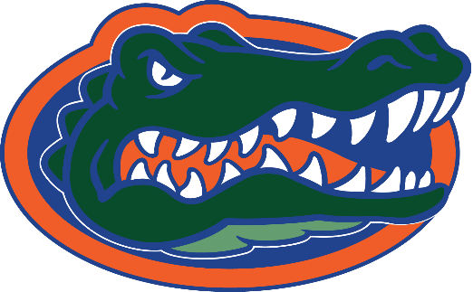

VS

6:30 A.M. Team Arrives at Home Stadium

6:45 - 7:30 A.M. Team Breakfast

7:30 - 8:00 A.M. Load Bus

8:00 A.M. Depart for Airport

9:00 A.M Arrive at Airport

9:30 - 11:00 A.M. Baggage Check/Board Plane

11:30 A.M. Flight leaves for Gainesville FL

3:30 P.M. Arrive at Gainesville airport

3:30 - 4:30 Obtain Luggage

4:30 P.M. Depart Airport

5:00 P.M. Arrive at hotel/check-in

5:00 - 6:00 P.M. Get Situated in the Hotel Rooms

6:00 - 6:30 P.M. Depart Hotel for Team Dinner

6:30 - 8:30 P.M. Team Dinner

8:30 - 9:00 P.M. Return to Hotel

9:00 - 10:00 P.M. Team Meeting

11:00 P.M. Room Check/Lights Out

